1. **VENUE**
2. **JW Marriot Surabaya**

Price : IDR 550,500,000

Capacity : 1000 guests

Address : Jalan Embong No. 85-89, Kedungdoro, Kec. Tegalsari, Surabaya, 60261

Description : JW Marriott Hotel Surabaya is the splendid choice for you

who are seeking a luxurious treat for your wedding dream. Get

pampered with the most excellent services and make your

wedding dream come true by spending here. The highest quality service accompanying its extensive facilities will make you get the ultimate wedding experience. Enjoy luxurious treats and incomparable experience by

staying at JW Marriott Hotel Surabaya.

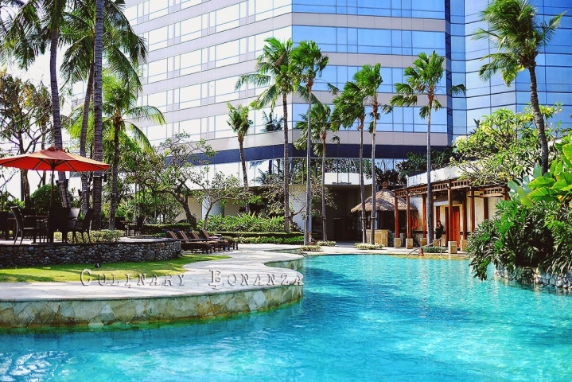

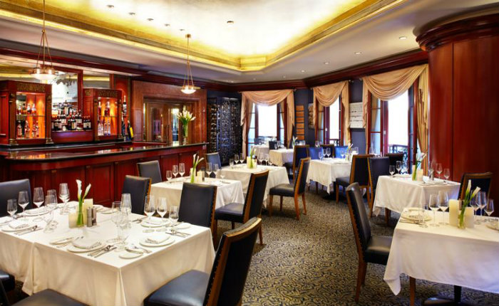

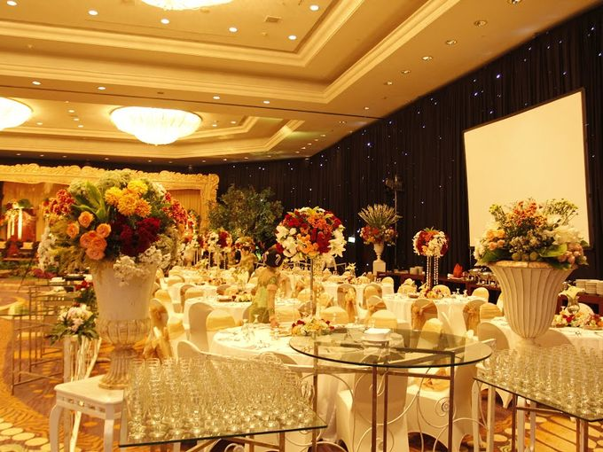

1. Sheraton Surabaya Hotel & Towers

Price : IDR 430,000,000

Capacity : 1000 guests

Adress : Jalan Embong Malang No. 25-31, Kedungdoro, Tegalsari, Surabaya, 60261

Description : Host a once-in-a-lifetime affair in the 804-square-meter Sheraton Grand Ballroom, which can also be separated into three smaller rooms. A romantic backdrop for both a ceremony and reception, it features the hotel's signature neutral palette with crimson accents and ornate carpeting. A similarly captivating attention to detail appears in the ornamental, recessed ceiling, which features sparkling chandeliers. The ballroom also features a 467-square-meter pre-function foyer. Ideal for pre-reception cocktails, it boast smooth marble floors, crown molding, and locally inspired accents. Seven additional venues are available to accommodate wedding events of all types.

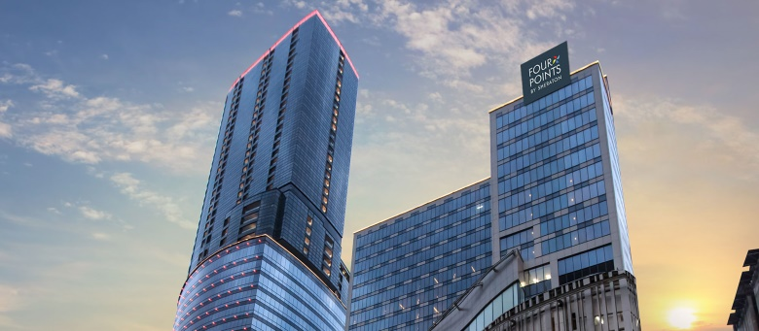

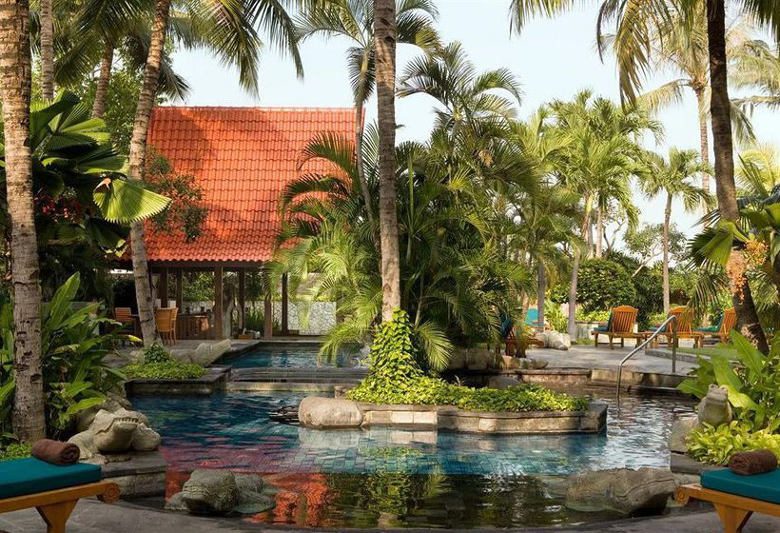

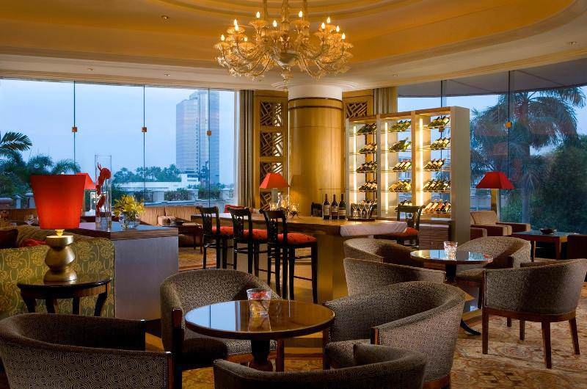

1. Dyandra Convention Center Surabaya

Price : IDR 575,000,000

Capacity : 3000 guests

Adress : Jalan Basuki Rahmat No 93-105, Surabaya

Description : A world-class quality and fully-integrated venue for MICE activities, wedding or any personal/corporate events with values of prime location and personalised

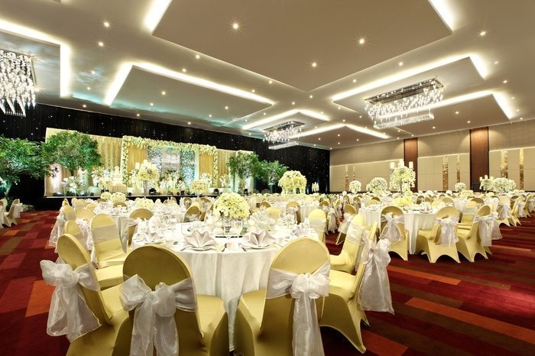

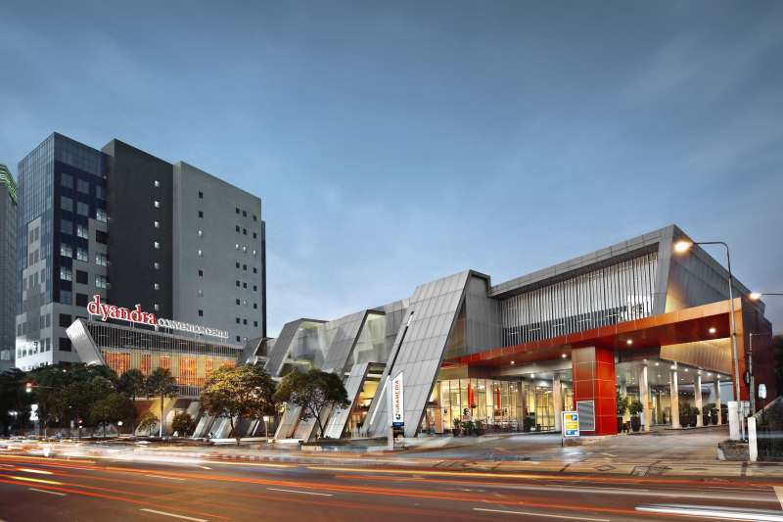

1. Ciputra Golf, Club & Resto Surabaya

Price : IDR 250,750,000

Capacity : 2000 guests

Adress : Jalan Citra Raya Utama, Lakarsanti, Surabaya, Jawa Timur, 60223

Description : Ciputra Golf, Club & Resto Surabaya has various kinds of event locations to effer, from the outdor spot at the terrace and aquatic driving range to the glamorous ballroom on the top of Palimanan Resto. Lash green scenery, the enchanting lake side venue, the romantic lights at night, the biggest capacity from 300 until 2000 people, this could actually be your dream wedding

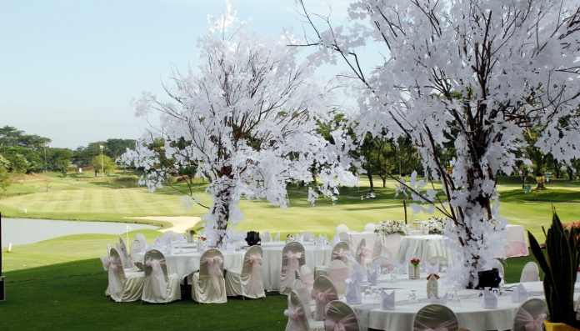

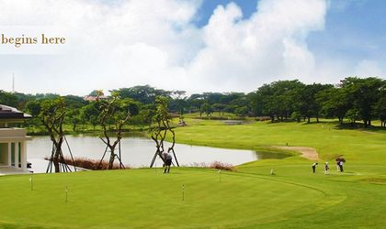

1. Pullman Surabaya City Center

Price : IDR 300,000,000

Capacity : 700 guests

Adress : Jalan Basuki Rahmat No. 67-73, Surabaya, Jawa Timur, 60271

Description : Pullman Surabaya City Center is the best choice to make your dream wedding come true. All the positive things will happen in here to fulfill your happiness on your happy day.

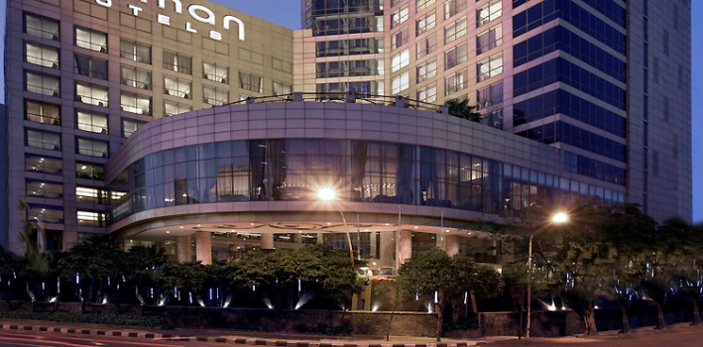

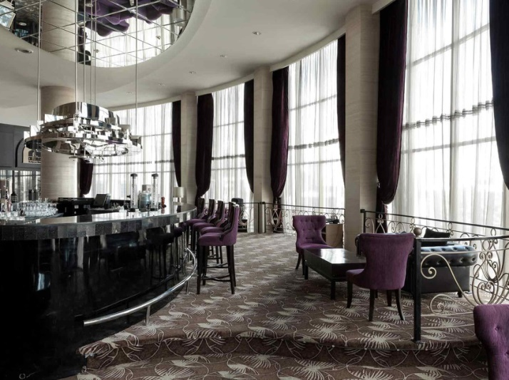

1. **ENTERTAINMENT**
2. **MALIK MUSIC ENTERTAINMENT**

Price : IDR 2.000.000

Description : Live music will set the tone for any event. Perhaps it’s a band ,acoustic, mini orchestra and orchestra for your wedding, or a violin for your process entrance, or maybe a harpist for your private party and etc. Whatever the event, you will find talented musicians right here on Malik Entertainment.

1. **PRIME MASTER OF CEREMONIES**

Price : IDR 1.500.000

Description : Master of Ceremonies (MC or emcee) is the host of your wedding and should make sure everyone is having a good time. A good wedding MC is more than someone who is good at public speaking or can tell a few jokes. They should make sure everything runs smoothly and introduce each person who is speaking, as well as important events.

1. **PARTY BAND GOLDSTONE**

Price : IDR 3.250.000

Description : Forget about cheesy top 40 party covers bands and take your event to the next level with our all female band. Providing an amazing live music entertainment option, our corporate party band puts on a 100% live concert your guests won't forget. A one of a kind female party band, Goldstone party band brings you the very best talent London has to offer.

1. **SELECTA BAND**

Price : IDR 2.750.000

Description : Bringing you the very best live music entertainment. Delivering sensational soul and perfect pop with slick choreography and glistening harmonies our party covers band lift events to the highest level. Appearing with their own pianist or supported by backing tracks, the experienced all female band bring their West End experience to events both intimate and grand with ever a touch of old school glamour.

1. **NIGHT FLIGHT MUSIC**

Price : IDR 4.000.000

Description : All your favourite chart topping hits performed alongside dazzling dance routines and powerhouse vocals. Modern and complete with all the current hits, this show is suitable for weddings, corporate parties or celebrations of any kind.

**3. DECORATION – LIGHTING**

1. **Silverdust Decoration**

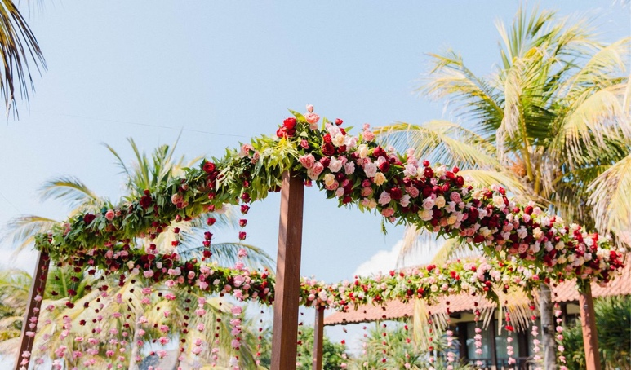

**ELEGANT DECORATION DINNER 150 PAX**

START FROM **IDR 120.000.000**/ 150PAX

*registration table set ( console table, 5 photo frames, simple flower arrangements)*

*1 set bridal table (6pax)*

*guest table set (optional)*

*15 sets for long table, 6 sets for round table*

*150 tiffany chairs*

*fairy lighting*

*standard lighting ( Par LED & hallogen)*

*genset*

**ELEGANT DECORATION DINNER 100 PAX**

START FROM **IDR 80.000.000**/ 100 PAX

*registration table set ( console table, 5 photo frames, simple flower arrangements)*

*1 set bridal table (6pax)*

*guest table set (optional)*

*10 sets for long table, 4 sets for round table*

*100 tiffany chairs*

*fairy lighting*

*standard lighting ( Par LED & hallogen)*

*genset*

**ELEGANT DECORATION DINNER 50 PAX**

START FROM **IDR 40.000.000**/ 50 PAX

*registration table set ( console table, 5 photo frames, simple flower arrangements)*

*1 set bridal table (6pax)*

*guest table set (optional)*

*5 sets for long table, 2 sets for round table*

*50 tiffany chairs*

*fairy lighting*

*standard lighting ( Par LED & hallogen)*

*genset*

1. **Eden Design**

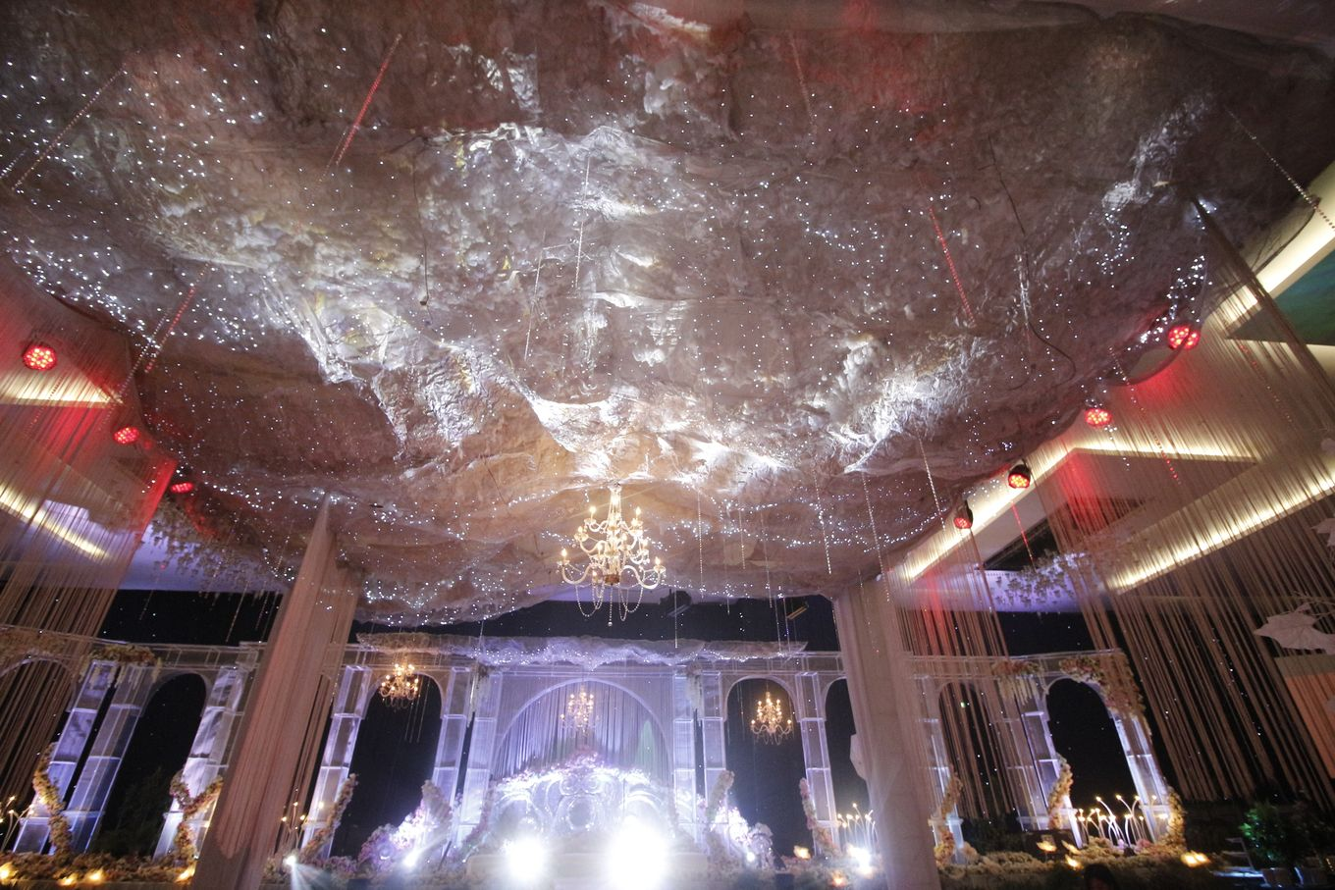

**ENGAGEMENT & INTIMATE OR PRIVATE PARTY**

FROM **IDR 10.000.000** TO **15.000.000** / THE WHOLE DESIGN & DECOR FOR 1 DAY PARTY

*Basic Decoration for private party such as Bridal Shower, Baby Shower, Bachellorete, Dinner, Birthday and Engagement include :*

*- Simple backdrop design for family photo (6-7m max)*

*- Gate entrance 1*

*- flower arrangement for special table setting 1*

**SMALL TO MEDIUM BALLROOM OR RESTAURANT DECORATION**

FROM **IDR 25.000.000** TO **65.000.000** / THE WHOLE DESIGN & DECOR FOR 1 DAY PARTY

*Beautiful Basic decoration for small to medium Ballroom or Restaurant Include: Ballroom Decoration :*

*Stage backdrop, gate entrance, standing flower, table setting VIP's area*

*Foyer Decoration : photo booth, photo gallery, backdrop for reception or angpao booth decoration*

**BIG AND SUPER BIG EVENT OR PARTY WITH SPECIAL DESIGN BY OUR ARTISTIC EVENT STYLIST**

FROM **IDR 65.000.000** TO **150.000.000** / THE WHOLE DESIGN & DECOR FOR 1 DAY PARTY

*Special design themed decoration Include:*

*Ballroom Decoration : Stage backdrop, garden decoration, catwalk and centerpoint decoration, gate entrance, standing flower, table setting VIP's area, Covers, Centerpoint*

*Foyer Decoration : photo corner, photo gallery, backdrop for reception or angpao booth decoration and all the foyer's area decoration with fresh flowers or mixed flowers arrangement*

1. **Elior Design**

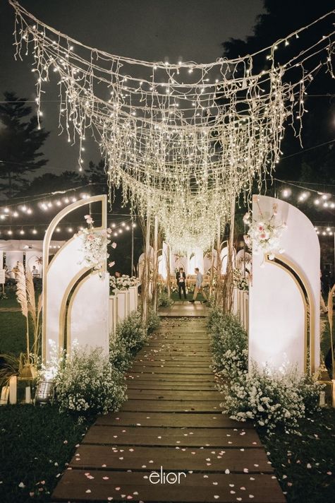

**OUTDOOR/SEMI-OUTDOOR**

FROM **IDR 45.000.000**/ 500

*- Design illustrations (Floor Plan, Elevations, Details -- if needed)*

*- Fresh flowers (No artificial flowers. Still possible with further discussion, also depends on the preferable spared budget)*

*- Entrance gate*

*- Reception desk*

*- Guest book*

*- Money box*

*- Aisle decor*

*- Semi-open stage background*

*- Band stage background*

*- Decorative lighting (ex. candles, lanterns, fairy lights, bulb / round lanterns, etc)*

1. **APLUS DECORATION**

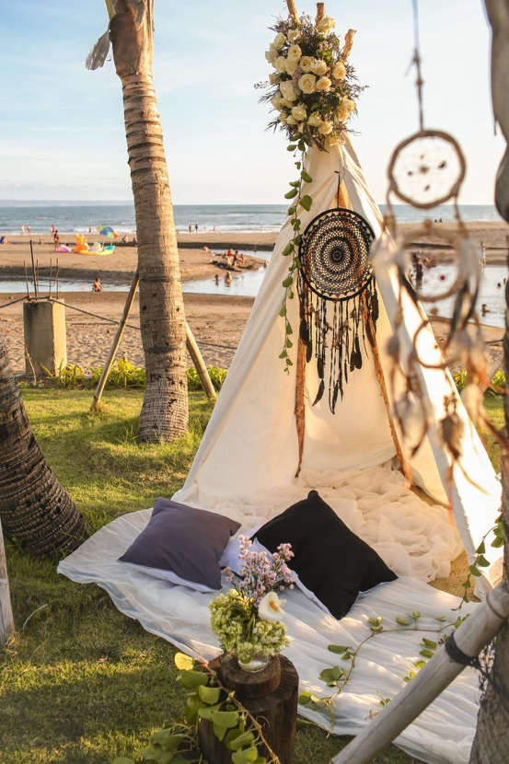

**PAKET DEKORASI RUSTIC**

FROM **IDR 30.000.000**/ 400

*Aisle decoration with fresh flower*

*setup tabel with flower*

*handbouqet*

*etc*

**4. PHOTOBOOTH**

1. **Lolphotobooth.co**

**3 TO 5,5 HOURS PHOTO BOOTH SERVICE**

FROM **IDR 6.000.000** TO **7.500.000** / SESSION

*Price:*

*1. 3 hours unlimited with 4R/2'x6' photo strip print with custom photo template, props and online soft copy access*

*2. 5,5 hours unlimited with 4R/2'x6' photo strip print with custom photo template, props and online soft copy access*

1. **iPhoto Photoprint**

**QUOTA - 200 PCS**

**IDR 2.000.000**/ 3 HOURS

*All package include :*

*Professional photographer & assistant*

*Studio lighting*

*Direct photo 4R*

*Exclusive photo frame*

*Customized border on photo*

*Fun props*

*All data on flashdisk (also available for other requirement below 200 pcs)*

**QUOTA - 250 PCS**

**IDR 2.400.000**/ 3 HOURS

**QUOTA - 300 PCS**

**IDR 2.700.000**/ 3 HOURS

**UNLIMITED PRINTS - 2 HOURS**

**IDR 2.700.000**/ 2 HOURS

**UNLIMITED PRINTS - 3 HOURS**

**IDR 3.000.000**/ 3 HOURS

**UNLIMITED PRINTS - 4 HOURS**

**IDR 3.300.000**/ 4 HOURS

1. **PRINTBOOTH INDONESIA**

**UNLIMITED LIVE INSTAGRAM PRINT PHOTO CORNER**

**IDR 3.500.000**/ 3 HOURS

*unlimited print photos | free design template photo | include 3 crew with smartphones | internet network | photo paper 4R with thermal printer | soft file inside goodie bag with Flashdisk on the spot/same day service | free social media promo | cute hat properties*